**SEMESTER 2 SKILLS TEST 6 – LIGHT NAME___________________**

***(23 Marks, 23 Minutes)***

1. Radar is used as a detection system through the production and detection of radio waves.

a. A transmitter is a conductor of electrons that is used to produce the radio waves that propagate through the air. Describe how the transmitter is able to produce radio waves. What type of power supply will be used? AC or DC?

[2 marks]

b. The radio waves produced have a 15.0 × 102 MHz frequency. Calculate the wavelength of the radio wave.

[2 marks]

c. Describe how a receiving antenna is able to detect radio waves. Also explain how it is able to isolate the waves originating from the transmitter yet ignore radio waves produced by other sources.

[3 marks]

d. The receiving antenna detects a radio wave 10.0 μs after it was transmitted. Calculate the distance between the transmitter and receiver.

[2 marks]

2. A microwave oven has a power rating of 1100 W and operates at 2650 MHz.

a) What is the energy of each photon produced? [2 marks]

b) How many photons are produced in 3 minutes? [2 marks]

3. The diagram shows the electric field component of a beam of polarised light being directed through a polariser into a photosensitive material behind. The photosensitive material records the intensity of the light reaching it.

Polariser

Photosensitive material

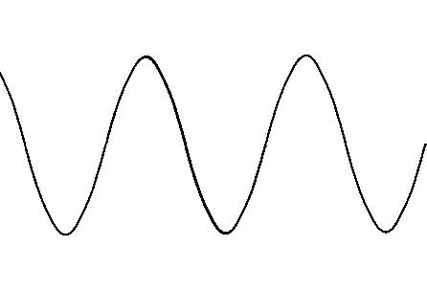

Polarised Light beam

a) Describe what polarised light is. [1 mark]

b) The photosensitive material detects high intensity in the current arrangement. The polariser is slowly rotated 1800 about an axis parallel with the light beam as the light continues to shine. Describe how the intensity of the light, as measured by the photosensitive material is affected during the rotation, if at all.

[2 marks]

c) Describe how the polarisation phenomena provides evidence supporting either light is a transverse or longitudinal wave how it excludes the other option.

[2 marks]

4. A photoelectric cell contains an aluminium electrode that is illuminated with ultraviolet light of wavelength 284 nm. The work function of aluminium is 4.08 eV. Calculate

(a) the energy of one of the ultraviolet photons in electron-volts.

(2 marks)

(b) the maximum velocity of the emitted photo-electrons. (3 marks)